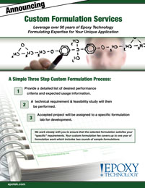 | Epoxy Technology provides custom formulating services to our customers. Leveraging our over 50+ years of specialty adhesive formulating expertise for your unique application to ensure that we meet your specific formulation requirements.

