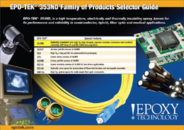
Epoxy Technology presents a new comparative piece focused on the industry standard, EPO-TEK® 353ND, and it's related family of products used in semiconductor, hybrid, fiber optic and medical applications. This is a visual and informative piece showing where each product falls based on a variety of physical properties.

