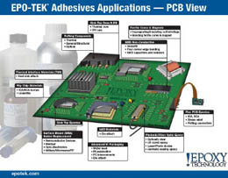
Epoxy Technology announces its latest offering for epoxy adhesive selection, our PCB Applications Guide. Applications include: IC Packaging, Ferrite Cores & Magnets, Flex PCB, Flip Chip, Glob Top, Glob Top Dam-N-Fill, LED, Photonic/Fiber Optic, Potting Compounds, SMD Non-Conductive, Surface Mount Adhesives/Solder Replacements and Thermal Interface Materials.

