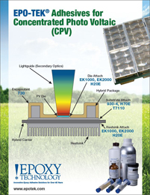 | Epoxy Technology offers a variety of specialty adhesives for your Concentrated Photo Voltaic (CPV) applications.

