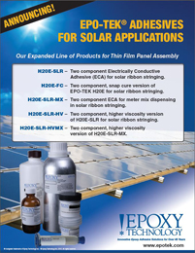 | Epoxy Technology announces an expanded line of solar adhesive products for thin film panel assembly.

