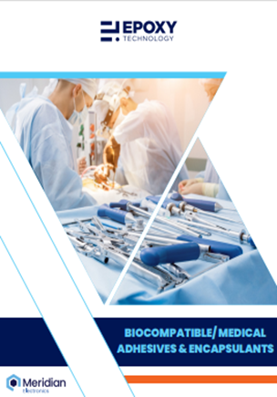 | Epoxy Technology, Inc. showcases its comprehensive line of EPO-TEK® Biocompatible/ Medical Adhesives & Encapsulant (“MED”) products. All EPO-TEK® MED products have undergone specialized ISO 10933 testing from an independent outside testing laboratory. This medical device adhesives brochure provides detailed adhesive property information as well as product specific recommendations for many medical applications including sensors, instruments, hearing aids, dental equipment, pacemakers, endoscopes and catheter products.

