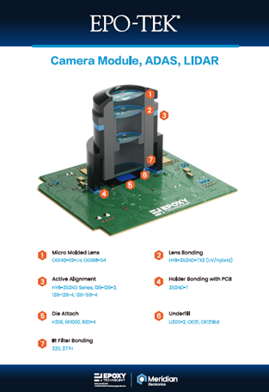 | EPO-TEK® specialty adhesives for photonics, featuring optical transmission, thermal management, active alignment and NASA/MIL-STD/Telcordia-certified low-outgassing solutions.

