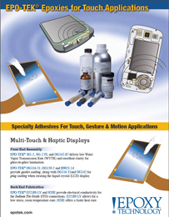 | From front end assembly...to back end display manufacturing, Epoxy Technology provides specialized epoxy adhesives for touch applications including: touch, gesture & motion, multi-touch & haptic display markets. These products are formulated for exceptional quality and reliability.

