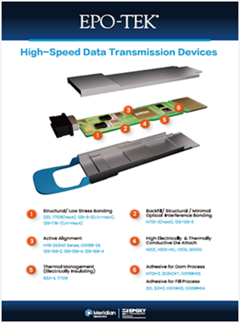 | Discover EPO-TEK® specialty adhesives engineered for fiber optic assemblies and optoelectronic devices.

