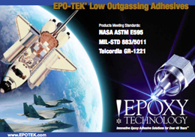
Epoxy Technology announces its newly updated Low Outgassing Adhesives brochure which includes several products that now meet the NASA ASTM E595, MIL-STD 883/5011 and Telcordia GR-1221 Standards. This brochure allows users to select the most appropriate EPO-TEK material; meeting the most stringent requirements necessary in critical designs.

