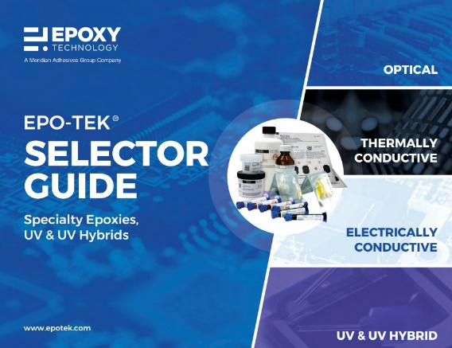
Detailed product information on our specialty adhesive product lines: Optical Adhesives, Electrically Conductive Adhesives (ECA), Thermally Conductive Adhesives (TCA), UV & UV Hybrids.

