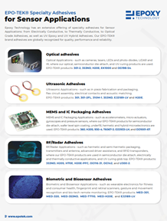
Learn more about our specialty adhesives for sensor applications.

