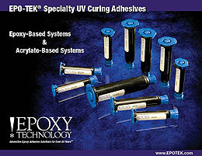
Epoxy Technology, Inc. offers a complete line of high performance Ultraviolet (UV) cure adhesives ranging in viscosity, flexibility, refractive index and light transmission.

