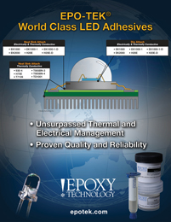 | Epoxy Technology showcases their extensive line of LED adhesives for both Low Power (LP) and High Power (HP) LED systems. These products include electrically conductive, thermally conductive and electrically & thermally conductive materials.

