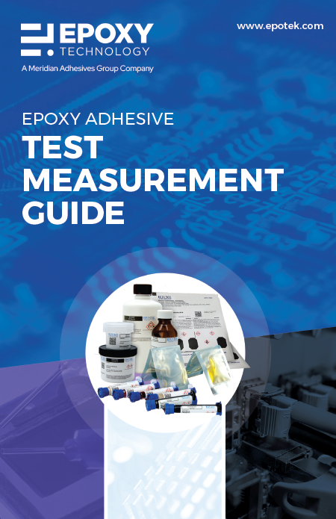 | Epoxy Technology offers this educational tool designed to assist adhesive users in gaining a more thorough understanding of adhesive properties and testing. The information contained within this guide is useful and invaluable for choosing the best adhesive in your specific application.

