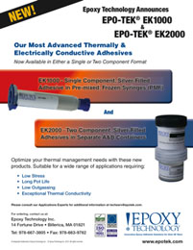 | Epoxy Technology announces EPO-TEK® EK1000 & EPO-TEK® EK2000. These new silver filled adhesives exhibit exceptional thermal & electrical conductivity and are now available in either a single or two component format.

