Highly Engineered & Enhanced Dispensing Products
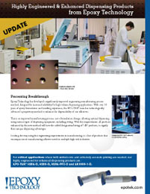 | Utilizing a significantly improved engineering manufacturing process method, Epoxy Technology offers adhesives with Enhanced Dispensed Properties (designated/listed  as “-D”). These materials increase the reliability of high volume dispense applications by minimizing the potential for skips or misses in the dispense process, while allowing for smaller and more accurate dot sizes.

