How to Interpret a Datasheet
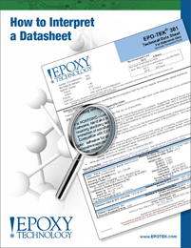 | When selecting an EPO-TEK® product for any application, the datasheet provides excellent information, and is a useful first reference guide. It is therefore important that the datasheet be correctly interpreted in order to achieve the expected properties and to avoid problems with any given product.

