How To Work Properly With Epoxies - Step by Step Sheet
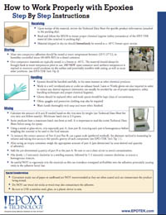 | Epoxy Technology announces its new instructional sheet on how to work properly with epoxies from initial receipt of the material, appropriate storage & handling, surface preparation, mixing, applying as well as choosing the most applicable cure profile.

