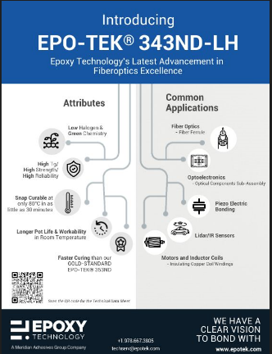 | Epoxy Technology’s Latest Advancement in Fiberoptics Excellence, EPO-TEK® 343ND-LH, for your fiber optic and semiconductor applications.

