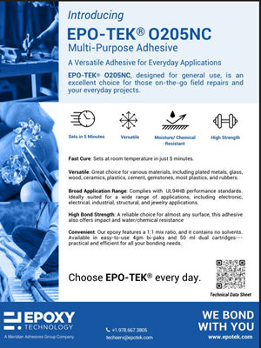 | Epoxy Technology’s Latest Offering, EPO-TEK® O205NC, is designed for general use and is an excellent choice for those on-the-go field repairs and your everyday projects.

