Thermal Management Brochure
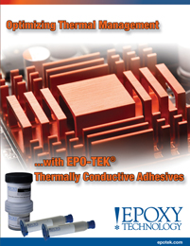 | Epoxy Technology presents a comprehensive overview of thermal conductivity & management using EPO-TEK® products. It highlights our most advanced products: EPO-TEK EK1000, EK1000-1 & EK2000. These cutting-edge, silver-filled adhesives exhibit exceptional thermal/electrical conductivity and provide superior performance in high reliability applications.

