Syringe Packaging
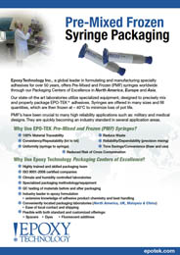 | Epoxy Technology announces our worldwide syringe packaging capabilities with certified laboratories in North America, Europe and Asia. All locations utilize our specialized packaging equipment. With extensive experience in epoxy formulation and handling, we are able to best package EPO-TEK® materials for optimal p

