Biocompatibility Testing of Adhesives
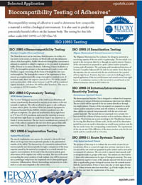 | Biocompatibility testing of adhesives is used to determine how compatible a material is within a biological environment. It is also used to predict any potentially harmful effects on the human body. The testing for this falls either under ISO 10993 or USP Class VI.

