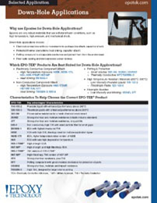 | Epoxy Technology presents various high temperature epoxies suited for down-hole applications that include die attach, heat sinking, capacitor attach, potting, fiber optics & sensors.

