[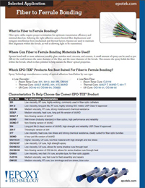](https://www.epotek.com/site/files/brochures/pdfs/Fiber_to_Ferrule_SAS(1).pdf)Epoxy Technology offers several optical adhesives for fiber to ferrule bonding.  These products range from high to low viscosity and are grouped by the following cure types: room temperature, thermal and UV.