Hard Disk Drive Application Guide
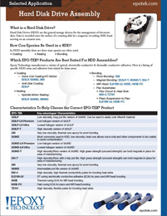 | Epoxy Technology specializes in a large selection of epoxies (including low halogen materials) used in many coating, sealing and bonding applications required in hard disk drives.

