Epoxies in Preservation and Restoration
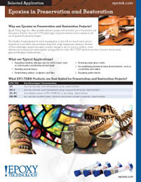 | Epoxy Technology offers specialty adhesive epoxies well suited for use in Preservation and Restoration Projects.

