Ultrasonic Application Guide
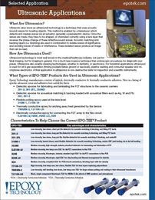 | Epoxy Technology provides optical, thermally conductive and electrically conductive adhesives for ultrasound technology in the medical/heathcare, electronics, oil & gas and non-destructive testing fields.

