Underfill Guide
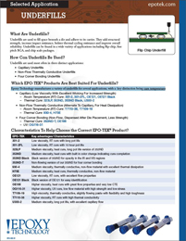 | Epoxy Technology manufactures a variety of underfills for several applications, with a key distinction being cure temperature.

