**Component Selections for Optimal Dispensing of Epoxies**

[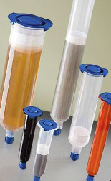](https://www.epotek.com/site/files/Techtips/pdfs/Tech_Tip_10_-_Dispensing_of_Epoxies.pdf)

|  |  |
| --- | --- |
| **What:** | Proper Dispensing Tips |
| **Why:** | Selecting the correct syringe (barrel), tip, piston & adapter is crucial for optimal dispensing. |