Converting Mix Ratios
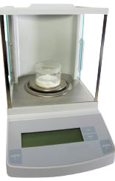 | What: Mix ratio by weight to mix ratio by volume  Why: Large errors can occur when mix ratios are not calculated properly

