Tech Tip 12 - Compatible Metallization
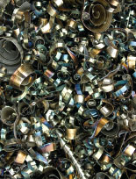 | What: Compatible Metallization for Silver Epoxies  Why: Considerations for PCB & circuit assembly when choosing ECAs ahead of solder joining

