Tech Tip 19 - Understanding Mechanical Properties of Epoxies for FEA
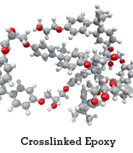 | What: Mechanical Properties of Epoxies for FEA  Why: Understanding the properties of epoxies will help in product selection when using FEA

