Handling Premixed and Frozen Materials
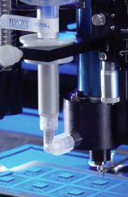 | What: Handling Premixed & Frozen Materials  Why: Touching the barrel of a frozen syringe without gloves will result in the product pulling away from the barrel and cause freeze thaw voids.

