Tech Tip 21 - Epoxy & Silicone Interactions
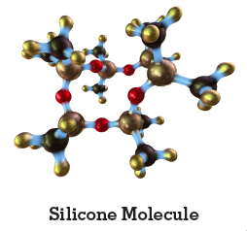 | What: Epoxy and Silicone Interactions  Why: Epoxies and Silicones can co-exist favorably within the same application when applied properly.

