Tech Tip 22 - Using Mold Release Agents with Epoxy Adhesives
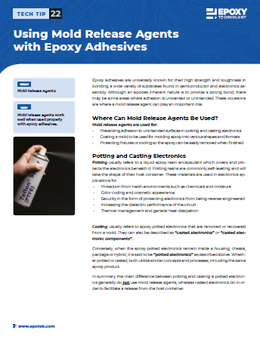 | What: Mold Release Agents  Why: Mold release agents work well when used properly with epoxy adhesives.

