Tech Tip 25 - Dielectric Properties of Epoxies
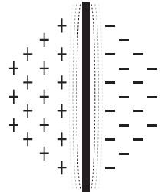 | What: Dielectric Properties of Epoxies  Why: Dielectric materials provide an insulating barrier between two electrical conductors.

