Tech Tip 26 - Pot Life, Working Life and Gel Time of Epoxies
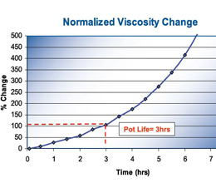 | What: Understanding the terms pot life, working life and gel time with regards to EPO-TEK adhesives.  Why: Knowing the difference will help with material selection for a specific application.

