Tech Tip 27 - Polyimides
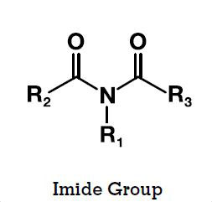 | What: Understanding Polyimides  Why: Polyimides are high temperature materials with excellent chemical and solvent resistance

