Tech Tip 28 - Amine Blush
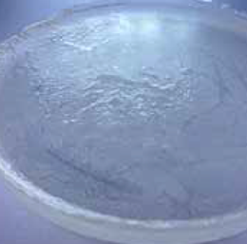 | What: Amine Blush with Epoxies  Why: Amine blush can be avoided with appropriate precautions.

