Tech Tip 29 - Gamma Sterilization for Medical Devices and its Effect on Epoxies
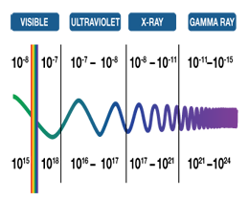 | What: Gamma Sterilization for Medical Devices and its Effect on Epoxies  Why: Irradiation can cause some changes to epoxies.

