Removing Bubbles
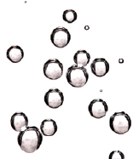 | What: Removing Bubbles from Epoxy  Why: Removing bubbles ensures optimal adhesive performance by providing a good continuous bond.

