Tech Tip 5 - Using Expired Product
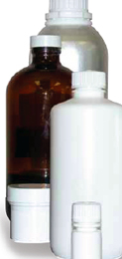 | What: Shelf Life  Why: A product can be used for certain applications after the date of expiration has passed.

