Tech Tip 6 - Minimum Bond Line
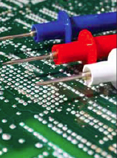 | What: Minimum Bond Line  Why: Minimum bond line cure and thickness play an important role in adhesive properties and performance.

