Tech Tip 7 - Epoxy Crystallization
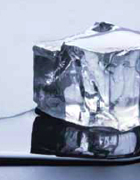 | What: Epoxy Crystallization  Why: Crystallization of epoxy resins is completely reversible, like freeze/thaw cycles of ice and water.

