Reworking Cured Epoxy
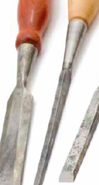 | What: Removing Cured Epoxy  Why: There are several techniques which have shown to be effective tools in removing cured epoxy from substrates.

