Tech Tip 9 - UV Cure Adhesives
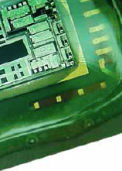 | What: UV Curing Tips  Why: UV curing adhesives offer a convenient way to quickly cure a product in specific applications.

