Fast Curing Electrically Conductive Adhesives (ECAs)
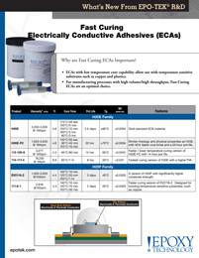 | Epoxy Technology, Inc. (EPO-TEK®) offers an expanded line of Fast Curing Electrically Conductive Adhesives (ECAs). These ECAs are ideal for low temperature cure capability allowing use with temperature sensitive substrates such as copper and plastics. Fast Curing ECAs are an optimal choice for manufacturing processes with high volume/high throughput.

