Flexible Electrically Conductive Adhesives
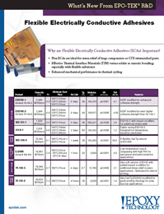 | Epoxy Technology presents New Flexible Electrically Conductive Adhesives. These materials are ideal for stress relief for large components or CTE mismatch parts. They also can enhance mechanical performance in thermal cycling.

